SECURE FILE STORAGE SYSTEM WITH ENCRYPTION AND ROLE-BASED ACCESS CONTROL (RBAC)
Scope and Limitations
Department of Computer Science and Engineering, TKR College of Engineering & Technology
Batch C13 (CSE-C) · Academic year [ACADEMIC YEAR]
Table 1: Project team
S.No. | Student name | Roll number
1 | Pramod Reddy Yalala | 23K91A05J9
2 | Pendela Vyshnavi | 23K91A05J1
3 | Luke Abraham Sam | 23K91A05D4
4 | Mudavath Suresh | 23K91A05G2

Project guide: D V V Deepthi
Chapter and section numbers quoted in the text (for example Chapter 8 or Section 6.2) refer to the full project report, 17.Final Document. Figures and tables in this document are numbered from 1.

1. SCOPE
The scope follows the six batch objectives and what could be measured on one desktop. It is stated first as what the product and its measurements cover, then as what they leave out, so that a reader does not mistake an experiment for a product feature.

1.1 In scope
• Accounts and sessions: registration with a name, e-mail address and a password of at least 8 characters; bcrypt-hashed passwords; JWT bearer sessions of 120 minutes; a throttle of 20 login attempts per 300 seconds for one address and e-mail.
• Key management in the browser: an RSA-2048 key pair generated at registration; the private key encrypted with an AES-256-GCM key derived by PBKDF2-HMAC-SHA-256 (120,000 iterations, 16-byte salt) and stored as a bundle on the server; the decrypted key held only in memory of the open tab.
• Files: encryption in the browser with a fresh 256-bit key and a 12-byte random IV, upload of ciphertext, IV, wrapped key and the SHA-256 of the plaintext, download with local decryption and hash comparison, replace-content, delete, up to 25 MB per file.
• Sharing and roles: share by e-mail or user id as Viewer or Editor with a key re-wrapped in the browser for the recipient; change role; revoke; per-file permission list; Owner / Editor / Viewer rules enforced on the server.
• Audit: a SHA-256 hash-chained event log for registration, login and logout, upload, download, update, delete, share, role change, revocation, denied access and chain verification; a verification route and screen.
• Interface and support: landing page, dashboard, file list, file detail, shared-with-me, audit log, security profile and vault unlock screens; dark and light themes; demo accounts with synthetic data; a REST API of 24 routes; automated tests and measurement and screenshot scripts.
• Deployment: one-command local run with SQLite; a Docker composition that selects PostgreSQL through DATABASE_URL.

1.2 Out of scope
• Attribute-based or policy-in-ciphertext access control, blockchain ledgers and any health-record specific processing, as in the base paper.
• Multi-factor authentication, password recovery or key escrow: losing the password loses the private key and with it every file.
• Re-encryption of existing files when access is revoked, and recall of keys or ciphertext a recipient has already downloaded.
• Chunked or streaming encryption of files larger than 25 MB, deduplication, versioning and file-name encryption.
• Cloud object storage (S3-compatible), hardware security modules or a key-management service; ciphertext stays on the local file system.
• A signed or externally anchored audit log, and administrative roles; the global role column exists but is not used for decisions.
• Penetration testing, formal verification and a usability study.
The table below sets the scope against the six batch objectives and the storage statement of the abstract, separating what the product does, what was measured and what was not done.
Table 2: Scope against the batch objectives
Objective | In the product | Measured | Not done
1 Registration and authentication | bcrypt cost 12, JWT HS256, 20 attempts / 300 s throttle | Login median 308 ms; forged, expired, wrong-secret and alg=none tokens all rejected | MFA, lockout across restarts
2 Encrypt every file before storage | AES-256-GCM in the browser; server stores ciphertext only | AES-GCM 25 MiB median 53.8 ms; 2,000 of 2,000 bit flips rejected | Files above 25 MB, chunking
3 RBAC and ownership | Owner / Editor / Viewer checked per request | 36 of 36 role-matrix cells as expected | Roles beyond three; admin role
4 Integrity on download | AES-GCM tag plus SHA-256 of the plaintext | Wrong key and altered ciphertext rejected | Signed hashes
5 Structured audit logs | Hash chain, 12 event types observed, verification screen | 8 of 9 tamper classes caught; verification of 5,000 entries 404 ms | Tail-truncation detection; concurrency safety
6 Evaluate overhead, access and integrity | scripts/measure_metrics.py and tests | 21 pytest, 17 API and 18 UI checks | Multi-user load, user study

2. ASSUMPTIONS
• The browser is the trusted endpoint: its Web Crypto implementation is correct and the device is not compromised. Endpoint security is outside the system.
• The server delivers the unmodified JavaScript of the application; a hostile server could ship altered code, which no part of the design prevents.
• A user chooses a password strong enough to resist guessing against the PBKDF2-protected key bundle, which the server stores.
• Public keys held by the server belong to the person named: no out-of-band verification of a recipient's key is performed, so the server could in principle substitute one.
• The audit log has a single writer at a time and the database is not edited by anyone able to recompute the chain.
• The measurements on one 12th Gen Intel Core i5-12500 (6 cores / 12 threads) desktop with 15.7 GB of memory, Chrome and Python 3.11.9 are indicative of a small local deployment; the machine also ran other jobs, so timings carry noise.
• The five demo files and the generated measurement files are fictional; no real personal or confidential data were stored.
• One user session per browser tab and a handful of users: the application was designed and measured for a single organisation, not for public scale.

3. LIMITATIONS

Cryptographic design
• Revocation is not recall. Revoking a share deletes the recipient's wrapped key on the server and stops further downloads (a download after revoke returned HTTP 403), but a recipient who already holds the file key or the plaintext keeps it. The file is not re-keyed.
• An editor's update reuses the file key. The new content is encrypted under the existing key with a fresh random 96-bit IV; the collision bound of GCM applies to very many updates, and the server cannot check that the new ciphertext and IV match.
• The server serves the code that does the cryptography. A compromised or malicious server could deliver JavaScript that leaks keys; this is the trust problem of deployed browser-based end-to-end encryption [8], and no content-security or integrity pinning is implemented.
• One password plays two roles. The browser sends the password to the sign-in route and uses the same password to derive the key that unlocks the stored private-key bundle. The server only keeps a bcrypt hash, but it sees the password at every sign-in, so a hostile server could attempt to open the bundle.
• Weaker key derivation than the closest related paper. PBKDF2 uses 120,000 iterations against 310,000 reported by the IJEDR paper [2]; no memory-hard function is used.
• Password loss means data loss. No recovery or escrow exists; this is stated to the user but is a real cost.
• Public keys are trusted as served. No key fingerprint check between users exists.
• The plaintext hash is stored in clear. The SHA-256 of each file sits beside the ciphertext, so a server-side reader holding a guess of a file's exact contents can confirm the guess.

Audit log
• Tail truncation is not detected. Removing the newest entries left a chain that still verifies (0 of 199 detected), because the verifier only checks internal consistency.
• A consistent rewrite is not detected. Anyone able to edit the database can alter an entry and recompute every later hash; the chain has no secret key and no external anchor.
• Concurrent writers fork the chain. The last hash is read and the new row committed without a lock; 100 concurrent failed logins on four workers left a chain that no longer verifies (first bad entry 5,047 of 5,145). The single-writer assumption is not enforced.
• The global event list is visible to every signed-in user through GET /api/audit, including other users' e-mail addresses and file identifiers.

Product
• Whole-file, in-memory encryption. Files up to 25 MB only; larger uploads are refused with HTTP 413 and there is no streaming or chunking.
• Metadata in clear. File name, size, MIME type, owner and timestamps are stored unencrypted so that listing works.
• Session and throttle. The JWT lives in sessionStorage and is exposed to script injection in the page; the login throttle is in memory and resets on restart; no refresh or server-side logout revocation of a token exists.
• SQLite by default. The abstract names PostgreSQL; it is supported through DATABASE_URL and the Docker composition, but the PostgreSQL path was not run in this work.
• Single-node local storage. Ciphertext is on the local file system and the application has no replication or backup.

Evaluation and process
• One shared machine. All timings come from one 12th Gen Intel Core i5-12500 (6 cores / 12 threads) desktop with 15.7 GB while other programs were running; run-to-run spread reached about three times at 10 MiB, so differences of a few milliseconds in the encrypted-against-plain comparison are inside the noise.
• Browser timer resolution. Chrome's clock steps in 0.1 ms, so the 1 KiB and 64 KiB operations were timed in batches of 200 and are averages.
• Exhaustive, not statistical, access checks. The role matrix proves the implemented rules for one file and four principals; it is not a user study and does not include concurrent edits.
• Synthetic data and no user study. No real users, no usability test and no independent security audit were carried out; the evaluation script's own browser-labelled timings are Python timings and were superseded by the Chrome measurements.

How the limits affect the reading of the results
The access-control and integrity results are the most dependable part of the work because they are exhaustive over the implemented operations and use a deterministic pass or fail. The timing results are indicative of a small local deployment, not benchmarks. The audit results show what a plain hash chain can and cannot promise: it detects edits, deletions, swaps and insertions, it does not detect removal of the tail or a full rewrite, and it needs a writer lock and an external anchor before it can be called tamper-evident in a hostile setting.
Two figures show the limitations that matter most for reading the security claims. The first shows how many of the nine audit-log tampering classes were detected by the hash-chain verifier: eight of nine are caught, but truncating the tail of the log is not. The second shows the end-to-end cost of encryption against a plain transfer on the same endpoint, measured on a machine that other processes were also using, so the timings are indicative.
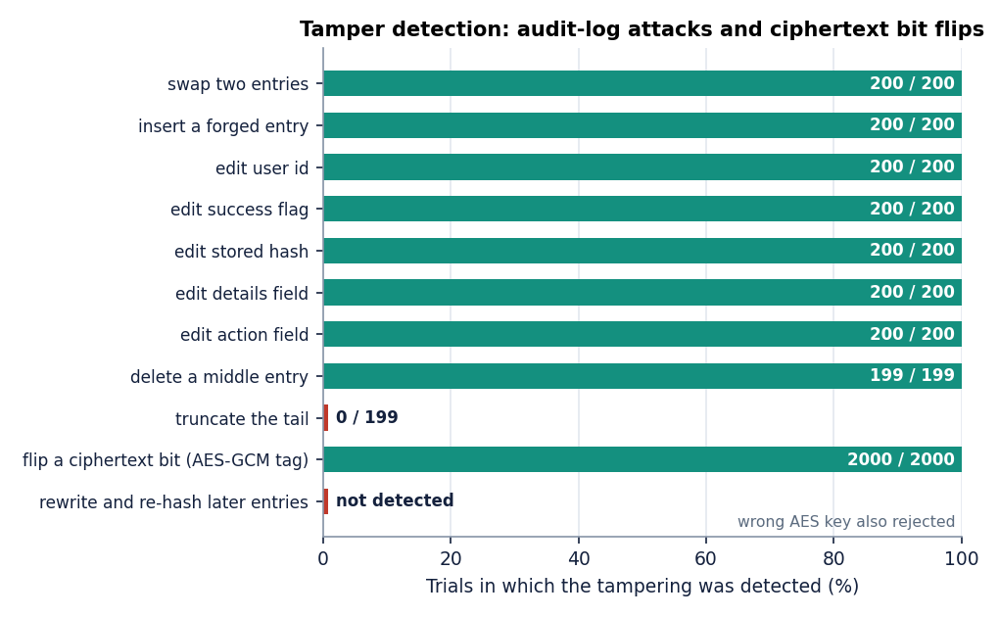
Figure 1: Detection rate of each audit-log tampering class, including the undetected tail truncation.
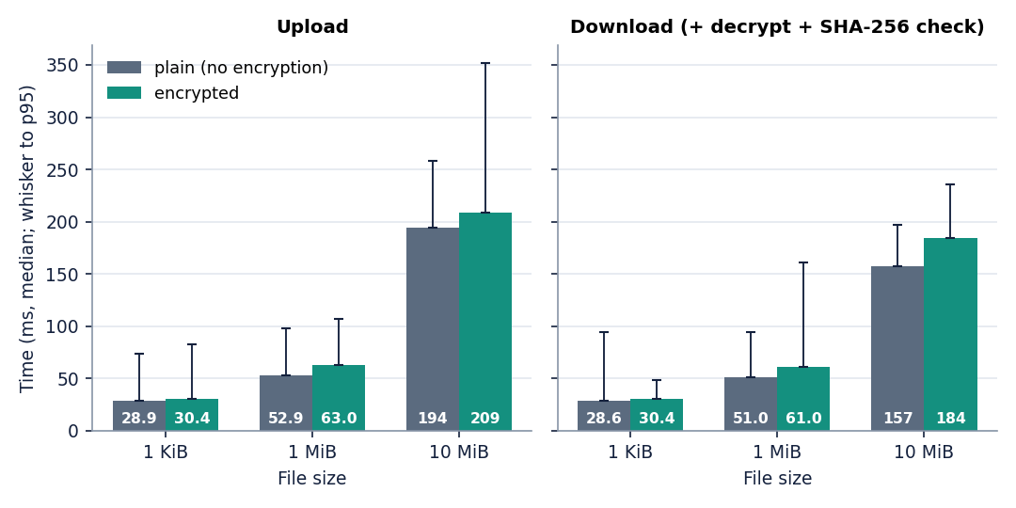
Figure 2: End-to-end browser pipeline against a plain transfer on the same endpoint.

4. WHAT WAS NOT MEASURED
The following were not measured, so no document claims anything about them. Each is either outside what the product does or beyond what one desktop and a short project could test.
• Behaviour under many simultaneous users: only one concurrency test (100 failed logins on four workers) was run, and it exposed the audit fault.
• Files larger than 25 MB and memory use of whole-file encryption near the cap.
• Firefox, Safari, mobile browsers beyond a 360 px layout check, and older browsers without the Web Crypto features used.
• The PostgreSQL path and the Docker image build; only SQLite on Windows was exercised.
• A screen-reader accessibility audit; keyboard use and reduced-motion support were provided but not assessed by users.
• Usability for real users, perceived waiting time and error recovery.
• Security by an independent party: no penetration test, no code audit and no side-channel analysis.
• Long-term storage behaviour: backup, restore, disk-full and crash recovery.
• Network conditions other than loopback: all API timings exclude real network latency.
None of these is hidden in a headline number. The statements of the abstract about cloud storage and professional key management are treated as future scope, not results.

